Group 3 - Adam, Divya, Mason, Michael, Morgan

Dr. Johnson

EECS 448

11/18/2021

**Project 4 Requirement Artifact - User Interface Model**

Pygame running window:

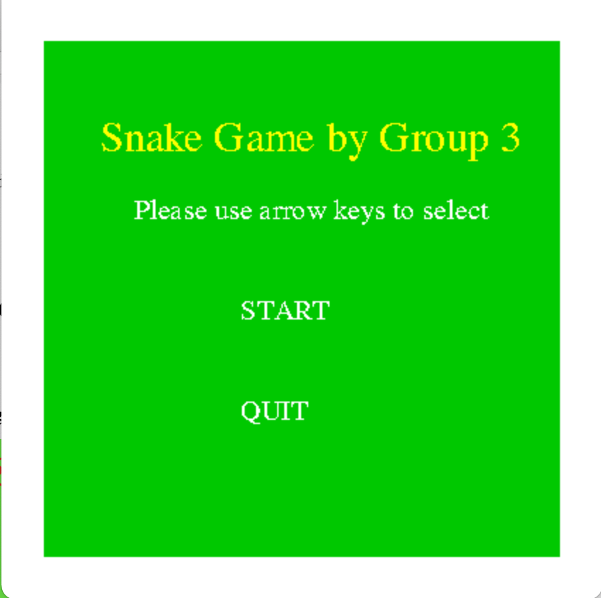

NEW: Front page with title and start/quit option

‘Enter’ to select

GOAL: Add instructions

Key Commands:

Only allows arrow keys

NEW: Difficulty

Highlighted choice indicated by yellow and larger font

GOAL: Add speed choice OR grid choice depending on difficulty

GOAL: Change colors to be more visual-friendly

NEW: Board is gridded

NEW: Border to help player stay inside of board

NEW: Termination leads to loss screen, and then returns to main menu (Picture 1)

GOAL: Match snake/food grid with display grid for ease of play

Possible Class Additions:

N/A

Possible Function Additions:

Print menu

Show grid

Difficulty

Highlight choice